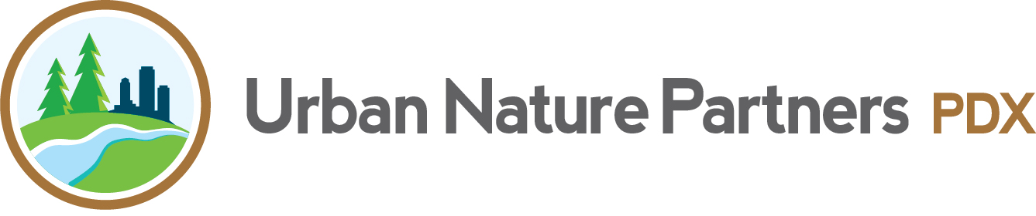

INTERNSHIP OPPORTUNITY: ADMINISTRATIVE ASSISTANT
20 weeks/ 2 school terms: approximately January 6, 2019- June 1, 2019 (excluding 1 week break)
average 8 hours/week, qualifies for college credit
occasional weekend and evening work required
stipend of $10/hour
personal transportation recommended
fluent Spanish speakers and candidates from diverse socio-economic backgrounds encouraged to apply
Urban Nature Partners PDX is a growing nonprofit entering its 6th year that matches youth in 4th through 9th grades from underserved Portland neighborhoods with mentors to spend regular time outdoors in urban greenspaces. Since spring 2014, we have brought our program to 40 youth in three diverse, low income areas of Portland, and have developed numerous partnerships with other dynamic Portland environmental and educational organizations to leverage opportunities for our youth and families. We are the only Portland based nonprofit providing long-term, relationship based, non- curricular, youth focused outdoor opportunities for young people in this age group.
This position is primarily responsible for assisting the Director and leadership team with administrative, planning, and program execution tasks of all kinds, including helping coordinate outdoor group outings for youth, mentors, and families. Term may be extended into summer 2019 and beyond if agreed upon by both parties. This position also provides the opportunity to serve on the Board of Directors, or the Advisory Committee to the Board of Directors, for a 1-year term through February 2020 by separate agreement.
If you care about social justice, love youth and the outdoors, and want an amazing opportunity to get ground floor experience with the many facets of nonprofit management, this internship is for you!
An Urban Nature Partners PDX internship provides the following opportunities:
- Gain intimate knowledge of the nonprofit sector in a young and growing program
- Learn about funding sources, how to successfully apply for grants, and raise other funds
- Gain insight into the socio-economic challenges of youth in underserved neighborhoods
- Gain valuable information management and event planning skills
- Gain many professional contacts for current and future ventures
Responsibilities may include:
- Correspond professionally as a UNP-PDX representative staff public outreach events, assist with publicity materials and social media accounts/campaigns
- Assist with mentor and youth recruitment, selection, matching, and training as requested and qualified, including Spanish translation if applicable
- Interact with youth, mentors, and families in planning and facilitating group events
- Track and analyze hours, attendance, funds, demographics, and surveys of youth, families, and mentors; assist with data migration project to new software system
- Assist Board members with administrative tasks such as policy research and fundraising tasks; serve as a Board Member or on the Advisory Committee to the Board if desired (volunteer position through February 2020)
- Purchase program and youth materials with UNP-PDX funds
- Assist with fundraising activities, conduct grant research and assist with grant writing process
Please visit our website at urban-nature-partners.org and our Facebook page at facebook.com/urbannaturepartnerspdx for more information. Interested parties may also speak with former interns and current mentors.
To apply, please email or deliver an introduction/statement of interest along with a current resume or description of work and educational experience to: Founder/Director Kristin Bowling, Urban Nature Partners PDX, 14 NE Killingsworth St., Portland, OR 97211, urbannaturepartnerspdx@gmail.com, 541-281-7162.

